Exercise: Android Fragment
Document Number: |  | Issue Number:  Date:

TABLE OF CONTENTS
1 Exercise 1: Create a programming tutorial list with fragment. 2
1.1 Description 2
1.2 Create new Project. 3
1.3 Create new activity for List fragment 3
1.4 Design layout for List Fragment 3
1.5 Update List Fragment class. 4
1.6 Create new activity for Detail fragment 5
1.7 Design layout for Detail Fragment 5
1.8 Update Detail Fragment class 5
1.9 Design Main Activity layout 6
1.10 Update code in Main Activity 7

Exercise 1: Create a programming tutorial list with fragment.

Description
The purpose of this exercise is make students get familiar with Fragment in Android software development. At the end of this exercise, student knows and can use Fragment to build application.
Overview of project:
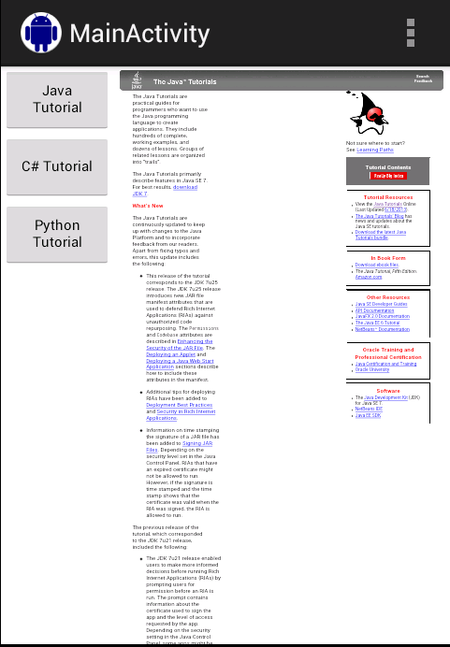

Create new Project.
In Eclipse, create new project with Build SDK: API 15 and Minimum Required SDK: API 11. Add Internet permission in AndroidManifest.xml.
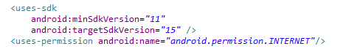

Create new activity for List fragment
In new Project, create new Activity for List Fragment. Delete this activity in AndroidManifest.xml.

Design layout for List Fragment
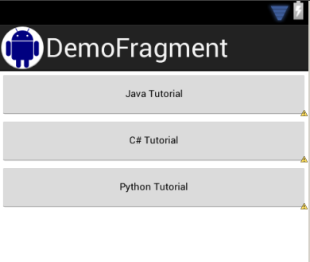
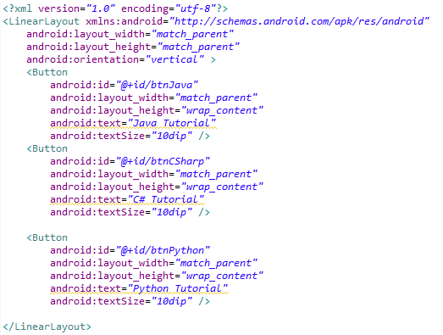

Update List Fragment class.
Note: use android.app.Fragment.
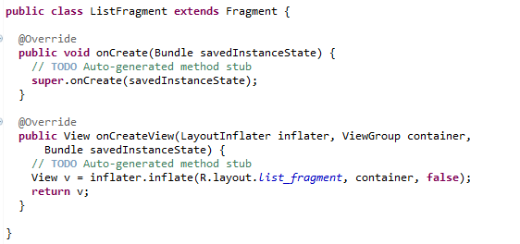

Create new activity for Detail fragment
In current Project, create new Activity for Detail Fragment. Delete this activity in AndroidManifest.xml.

Design layout for Detail Fragment
Note: add image name hourglass.png in res/drawable-mdpi.
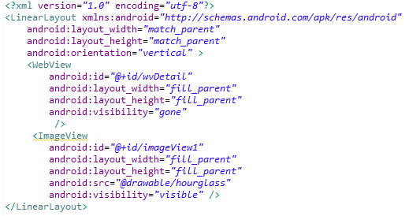

Update Detail Fragment class
Note: use android.app.Fragment.
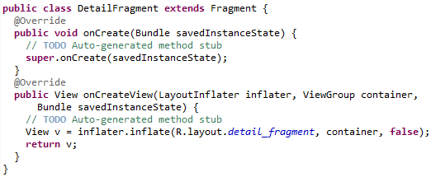

Design Main Activity layout
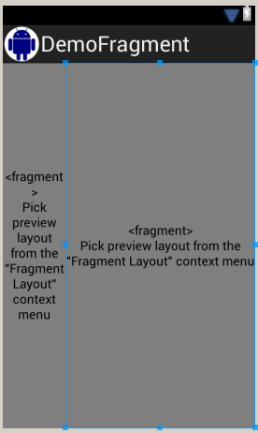

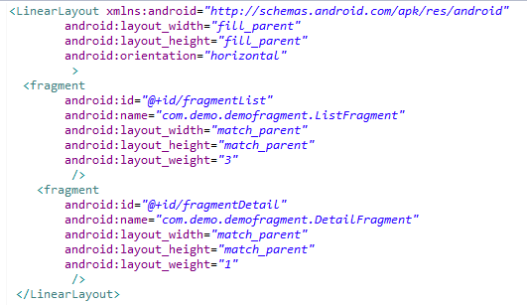

Update code in Main Activity

